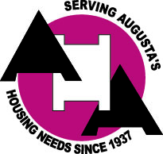

Public Notice
*Property Owners and Agents*

The Housing Authority of the City of Augusta, Georgia is currently seeking property owners and agents in the Augusta-Richmond County area for the Housing Choice Voucher (HCV) Program. If you have property that you are interested in renting, we may be able to assist you by listing your property on the HCV Availability List and at www.affordablehousing.com. To qualify for this program, the property must be located in Augusta-Richmond County, Georgia and must meet the U.S. Department of Housing and Urban Development’s Housing Quality Standards.

Below are the current rental rates that are paid for assisted units under the HCV Program:

Maximum Rents
0-Bdrm Up to $610 1-Bdrm Up to $690 2-Bdrm $630-$775
3-Bdrm $775-$900 4-Bdrm $875-$1000
Effective Date: 11/1/2021

